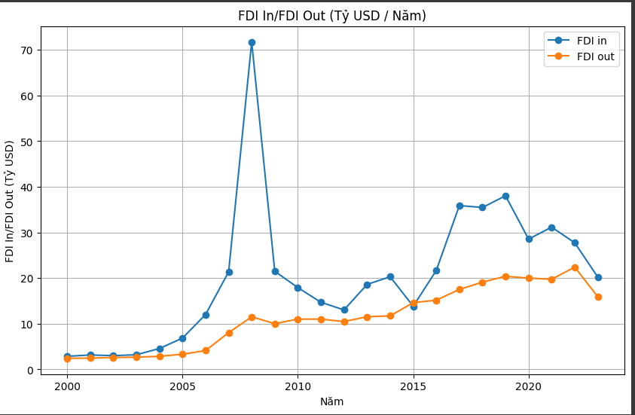

**Analysis of Vietnam's FDI In and FDI Out data from 2000 to 2023**

Based on the data in the figure, it can be seen that Vietnam's FDI In has grown steadily over the period 2000-2023, with an average annual growth rate of 22.2%. Vietnam's FDI Out also grew during this period, but at a slower rate, with an average annual growth rate of 11.3%.

**FDI In**

From 2000 to 2010: Vietnam's FDI In grew at a rapid pace, from 1.8 billion USD in 2000 to 14.5 billion USD in 2010. This growth was driven by a number of factors, include:

* Increased investment by multinational corporations in industries such as manufacturing, processing, and services.
* Vietnam's economy began to grow rapidly, creating many new investment opportunities.
* The Vietnamese government has issued many preferential policies to attract foreign investment.

From 2011 to 2020: Vietnam's FDI In continued to grow, but at a slower pace. In 2011, FDI In reached 18.5 billion USD, and in 2020 reached 28.5 billion USD. This growth is driven by a number of factors, including:

* Increased investment by Chinese investors in sectors such as real estate, industry, and services.
* Vietnam has signed many free trade agreements with countries and regions around the world, creating favorable conditions for foreign investors.
* The Vietnamese government continues to improve the investment environment.

From 2021 to 2023: Vietnam's FDI In continues to grow, reaching 31.1 billion USD in 2021 and 34.4 billion USD in 2022. This growth is driven by a number of factors, including:

* Vietnam's economy recovers after the COVID-19 pandemic.
* Vietnam continues to promote economic reform, creating favorable conditions for foreign investors.

FDI Out

From 2000 to 2010: Vietnam's FDI Out grew at a rapid pace, from 0.3 billion USD in 2000 to 2.5 billion USD in 2010. This growth was driven by a number of factors, include:

* Vietnamese businesses began to expand into foreign markets.
* The Vietnamese government encourages Vietnamese businesses to invest abroad.

From 2011 to 2020: Vietnam's FDI Out continues to grow, but at a slower pace. In 2011, FDI Out reached 3.2 billion USD, and in 2020 it reached 5.4 billion USD. This growth is driven by a number of factors, including:

* Vietnamese businesses continue to expand into foreign markets, especially into Southeast Asian and Chinese markets.
* The Vietnamese government continues to encourage Vietnamese businesses to invest abroad.

From 2021 to 2023: Vietnam's FDI Out continues to grow, reaching 6.5 billion USD in 2021 and 7.3 billion USD in 2022. This growth is driven by a number of factors, including:

* Vietnamese businesses continue to expand into foreign markets, especially into Asian markets.
* The Vietnamese government continues to encourage Vietnamese businesses to invest abroad.

**Conclude**

Vietnam's FDI In and FDI Out data from 2000 to 2023 shows that Vietnam has become an attractive destination for foreign investment. FDI has played an important role in promoting Vietnam's economic growth and development.

**THE REASONS IN 2008 FDI IN VIETNAM WAS A RECORD HIGH**

In 2008, registered FDI capital in Vietnam reached 71.7 billion USD, a record high in the history of attracting foreign direct investment. There are several key reasons for this growth, including:

* Joining the WTO: Vietnam officially joined the WTO in November 2006, opening up a large market for foreign investors.
* Stable economic growth: Vietnam's economy grew steadily during this period, with an average annual GDP growth rate of 8%.
* Preferential policies: The Vietnamese government has issued many preferential policies to attract foreign investment, including tax, land, and labor incentives.

In addition, a number of specific events also contributed to promoting FDI capital flows into Vietnam in 2008, including:

* Samsung Group opens a mobile phone factory in Bac Ninh: Samsung's factory is the largest FDI project ever implemented in Vietnam, with a total investment of 5.8 billion USD.
* Vingroup Corporation received an investment of 3 billion USD from TPG Group: This investment has helped Vingroup become one of the largest private corporations in Vietnam.
* Global financial crisis: The global financial crisis has caused foreign investors to look for new markets to invest, and Vietnam is one of the markets benefiting from this trend.

Overall, 2008 was a successful year for Vietnam in attracting foreign investment. Record FDI capital inflows have contributed to promoting Vietnam's economic growth and development.

**WHY PERIOD 2017-2019 FDI RECORDED A RECORD HIGH AND RETURNED TO THE OLD POSITION WITHIN 1 YEAR**

There are two main reasons leading to the sudden growth of FDI In Vietnam in the period 2007-2008 and the rapid decline within just 1 year afterward:

Cause of growth

Vietnam joined the WTO in 2007: This is an important milestone in Vietnam's international economic integration process. Job